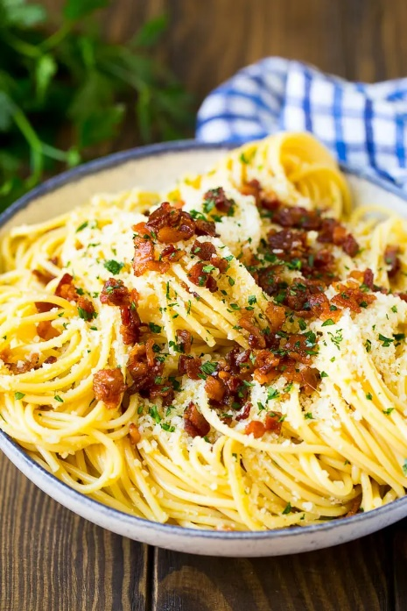
Carbonara Pasta
Prep time 5 min Cook time 15 min
2 Servings
Ingredients
4 oz spaghetti
10 slices of bacon
½ tsp minced garlic
1 whole egg
2 egg yolks
½ cup parmesan cheese
Directions
- Cook the spaghetti according to package directions. Reserve ¼ cup of pasta cooking water.
- Cut the bacon into ¼ inch pieces and cook it in a large pan over medium high heat. After it is cooked, drain all the grease off except for 1 tablespoon. Add the garlic and cook for an additional 30 seconds.
- In a medium bowl, whisk together the eggs, egg yolks and parmesan cheese.
- Add the cooked spaghetti to the pan with the remaining bacon and toss to coat in the bacon fat.
- Remove the pan from the heat and pour the egg and cheese mixture in the pan. Toss the sauce with the hot pasta for 2-3 minutes or until sauce has thickened.
- Whisk in 1 tablespoon of cooking water at a time, as needed to thin the sauce to your desired consistency.

